Team Report

Contents

1 Names of team members. 2

2 Project Analysis 2

2.1 Background to the area. 2

2.2 Brainstorming Idea 1 2

2.3 Brainstorming Idea 2 2

2.4 Final Project description and feature list. 2

3 Project Design 2

3.1 List of components used and why 3

3.2 Description of software 3

3.3 Limitations of current design. 3

3.4 Potential future development ideas 4

4 Problems Encountered 4

4.1 Technical issues 4

4.2 Team Issues 4

4.3 Other problems 4

5 The project process 4

5.1 Managing the team 4

5.2 Brainstorming and idea generation 4

5.3 Managing the code using Git 4

5.4 Using Trello to help the process. 5

6 Links and reference 5

6.1 Team GitHub page. 5

6.2 Team Trello Page 5

6.3 Web resources used. 5

# Names of team members.

David Gordon S00189689

Jonatan Opitek S00189340

Mohamad Shiha S00189636

# Project Analysis

## Background to the area.

Taking care of your pet is important, so we came up with this idea to help pet owners to make it easier for them to take care of their pets.

## Brainstorming Idea 1

Room thermometers for heating (the group decided to go with Dog Hopper idea).

## Brainstorming Idea 2

* Theft detection for farmyards.
* Room thermometers for heating.
* Robotic Arm.

## Final Project description and feature list.

The final idea that we had and settled on was the ‘Dog Hopper’, as it presented a real-world Problem and solution. We envisioned that this idea would allow the user (pet owner) to dispense dog food via an app from anywhere in the world.

# Project Design

## List of components used and why

1. We useda a stepper motor to help dispense the food from the food chamber.

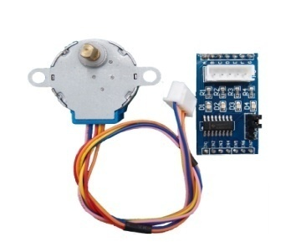

1. We also used a digital button to control the motor.

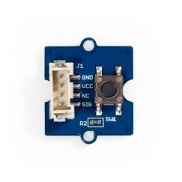

## Description of software

We found a library called CheapStepper to control the motor.

We are also using Bridge and blynk

The code is very simple, in the loop if the button is pressed turn the motor using the CheapStepper library.

Blynk is used to control the if statement with a virtual button.

Bridge is used with Blynk to connect to the Blynk servers.

The code is on Github it is commented and easy to read.

## Limitations of the current design.

Currently, the design is limited to a certain weight in the food chamber

If we had the equipment, we could have used a CNC Router to cut the parts better so we could acrylic weld them together to get a nicer finish.

## Potential future development ideas

The prototype and application could be sold as a package.

The size and power of each device could be differentiated as per the owner's needs.

We can make the device smarter, remembering when to feed the pet and how much.

# Problems Encountered

## Technical issues

* The material we used to make the prototype was an issue but David help us again and saved the day.
* After we found a good material it was hard to fit the motor and drill holes but David had some tools and great knowledge and experience handling the tools and working with this kind of materials, helped us again.

## Team Issues

Communication was a very hard part of this project as we all live in separate areas so therefore our only contact time was in college. We, as a group, are in different courses so our timetables are different and we each have different course requirements, halting us from meeting as freely as we would wish.

However, we worked well as a group.

# The project process

This chapter is to document how you worked as a team in project 2. Where necessary you should describe how it differs from what you did the first time around. Consider this as a way of documenting what you have learnt by going through the process twice.

## Managing the team

Managing the team was a hard part as we all had different visions, but after drawing the first prototype we had no problems dividing the task as we used Trello for that.

## Brainstorming and idea generation

It was hard to settle on an idea between the group as we all had varying ideas.

Once we decided however, we worked well as a group.

## Managing the code using Git

It helped us a lot using Github as it was easy to control the code specially the committing comments it was easy to know the last changes we made to the code

Also Github provided easy access to the project

## Using Trello to help the process.

Dividing the tasks and deciding what to do next is very important for the project to reach the point we envisioned it, Trello mad this step easy and clear to all group members on what stage the project is and what’s the next move is.

# Links and reference

## Team GitHub page.

## <https://github.com/S00189689/iot-Semester2>

## Team Trello Page

<https://trello.com/b/YYHMQqYx/iot>

## Web resources used.

1. <https://blynk.io/>
2. <https://github.com/tyhenry/CheapStepper>
3. We had to buy [Shafts](https://www.amazon.co.uk/Metric-Silver-Steel-Round-Lengths/dp/B01NCU7NSZ/ref=sr_1_1?s=industrial&ie=UTF8&qid=1551870679&sr=1-1&keywords=5mm+steel+shaft) and [belt](https://www.amazon.co.uk/KeeYees-Timing-Tensioner-Torsion-Printer/dp/B07JGXG7S2/ref=pd_day0_hl_328_4/261-9490537-7559249?_encoding=UTF8&pd_rd_i=B07JGXG7S2&pd_rd_r=30b581dc-4000-11e9-bd60-bf4de613e809&pd_rd_w=N9G5i&pd_rd_wg=lUnyi&pf_rd_p=92d624bb-a334-423e-) from Amazon.